
Powerstar Rendszerfejlesztési és Fõvállalkozási Kft.
H-1039 Budapest, Nagyvárad u. 11-17.
Tel: (36-1)-2400-350, (36-1)-2400-352 Fax: (36-1) 2400-349
Home-page: www.powerstar.hu E-mail: office@powerstar.hu

ISO 9001 IQNet CERTIFIED

Powerstar Complete Solar Systems PSCN range

PSCN-48/1000W 230V, 50Hz, 1000W continuous power, built-in possibility of 48V, 100Ah battery bank

PSCN-48/1500W 230V, 50Hz, 1500W continuous power, built-in possibility of 48V, 100Ah battery bank
PSCN-48/3000W 230V, 50Hz, 3000W continuous power, built-in possibility of 48V, 100Ah battery bank

ITEM | DESCRIPTION | PRICE (EUR) | SYSTEM DRAWING
PSCN-48/1000W  1000W continuous  3000W peak power | - Pure sine wave output  - Distortion: ≦3%  - Efficiency: ≧85%  - Regulation: ±2%  - No load current: ≦0.25A  - Frequency: 50/60HZ ± 1%  - Output voltage adjustable  - Green power function  - Temperature control Fan  - AVR  - Input & Output isolated  - Input low & high voltage prot.  - Input & Output short circuit prot.  - Low battery alarm & shut-down  - Overload protection  - Temperature protection: 50±5  - Remote control. (3 meter)  - Fast Action AC Synchronised Transfer Switch (UPS Mode) | Ask the dealer | 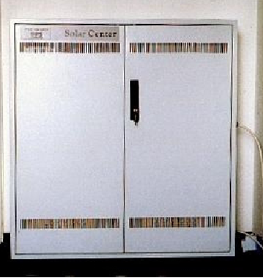  Dimension (H x W x D): 1000 x 800 x 250 mm
PSCN-48/1500W  1500W continuous  4500W peak power |  | Ask the dealer
PSCN-48/3000W 3000W continuous  6000W peak power |  | Ask the dealer

INPUT PARAMETERS

- AC input : 230V, 50Hz
- Battery charge current: 48V, 20A
- Photovoltaic input Voltage: 48V, nominal, max 120V
- Input solar current max: 60A

OPTION

- Built-in battery type: 48V, 100Ah maintenance free AGM battery

The system can work in UPS mode without solar modules. The standby time for an average office
is 5 –10 hours wih 48V, 100Ah batteries.

AURHORISED DISTRIBUTOR
WeilSolar Ltd. Hungary

Partner Company:
PHOENIX INTERNATIONAL.
HEAD OFFICE : 295, WEST RAMPURA ( 1ST FLOOR) , DHAKA-1219.
BREANCH OFFICE : 353/1 , D.I.T ROAD (4TH FLOOR) , EAST RAMPURA, DHAKA-1219
PHONE880-2-9333430,880-2-9336962, FAX ; 880-2-9333461,MOBILE : 88-01712709781
E-MAIL ; phoenix11869@yahoo.com

